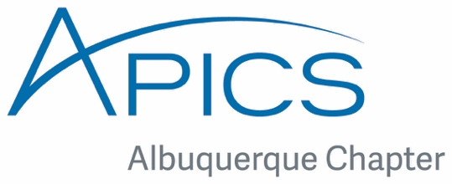

APICS is the leading professional association for Supply Chain and Operations Management.
August 2016 Newsletter
Welcome back to the New 2016-2017 APICS Year!!
I would like to welcome you to a new 2016-2017 APICS year. Hopefully you all enjoyed a relaxing summer. Thank you to all our members who participated in last year’s professional development meetings, community events and programs. This year we are planning several activities and tours to a variety of industries around Albuquerque. We hope you will join us to network and learn about supply chain, production, logistics and more.
This year we start with a new elected Board of Directors:
Debora Brener – President, Rosemarie Stansbury – Director of Programs,
Scott Keithley – Director of Finance, Kimberly Apodaca – Director of Membership,
Nataliia Mueller – Director of Administration and Liz Griego Powell -Webmaster.

PROGRAMS

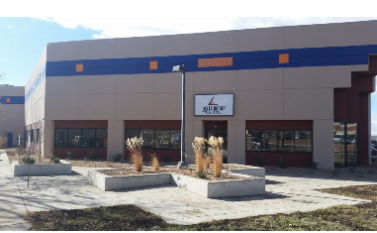

Lunch Tour at Delta Group Electronics Inc.
On August 24th at 11:30am. http://www.deltagroupinc.com 4521 Osuna RD. NE Albuquerque, NM 87109
Delta Group Electronics, Inc., established in 1987, is a high-mix medium volume to low-mix medium quantity run electronics manufacturing services (EMS) provider recognized by Inc. Magazine as one of the fastest growing small businesses in the United States. The company provides cost-efficient, high-quality assembly of custom wiring harness, cable and turnkey electronic assemblies for its business partners throughout the southern half of the United States. Based in Albuquerque, New Mexico, Delta Group also has assembly operations in Florida, Arkansas, Texas and southern California.

APICS is the leading professional association for Supply Chain and Operations Management.

The company maintains an ISO9001/AS9100 quality certification at each facility; along with ISO13485 quality standard at the San Diego, California location and NADCAP registration at the
Albuquerque, New Mexico location. The company also maintains an annual ITAR registration and compliance program to include Distribution D capability through an approved DD2345.
Delta Group maintains a diverse customer base, serving customers in defense, aerospace, telecommunications and capital equipment industries

Please RSVP to Rosemarie Stansbury at rosemarie.stansbury@eclipse.aero by 8/22/2016 to make your reservation. This event is limited to a maximum of 20 people, so hurry and RSVP soon. The cost of the tour is $10, students $5.

EDUCATION
Are you interested in achieving your CPIM certification?
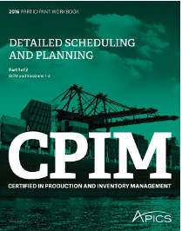
We will start a Detailed Scheduling and Planning (DSP) class in September.
Please send an email to contact@abqapics.org or call 505-331-8205

Detailed Scheduling and Planning
Acquire a working knowledge of the tools and techniques for planning of inventory, including planning techniques such as MRP, CRP, lean, TOC, and projects. Understand the effect of using each technique; know standard measurements for inventory, materials, capacity and supplier performance; and recognize when to escalate issues. Topics include:
- Managing inventory, planning material requirements, planning capacity requirements, and procurement and supplier planning
- Recognizing the importance of supply chain management and deploying supply chain strategies related to scheduling, planning, and sourcing
- Translating product-level plans and schedules generated at the master planning level into requirements that can be procured or produced
- Bridging the master planning area with the execution and control function
- Planning, scheduling, resource allocation, and implementing projects that are used to manage the supply of products and services 2017

APICS is the leading professional association for Supply Chain and Operations Management.

Events

APICS 2016

The flagship conference from the premier supply chain organization
If you attend just one supply chain conference this year, make it APICS 2016.
APICS 2016 is THE conference for professionals from all sides of the value chain, where you’ll gain relevant knowledge, foster relationships, explore trends, debate challenges and heighten efficiency. You and 2,000 professionals from more than 50 countries will experience a world-class education program that will take your career and your organization’s supply chain to new heights. Don’t miss it!
Each year, the APICS global conference imparts industry-leading knowledge that enables you to:
- Elevate supply chain innovation and resilience with valuable insights gained from industry leaders.
- Accelerate your career by networking with professionals who are shaping the future of supply chain, logistics and operations management.
- Learn best practices to create more sustainable, strategic and value-driven supply chains.

Elevate your supply chain and accelerate your career at APICS 2016.
September 25–27, 2016
Washington DC
Washington Marriott Wardman Park

For more information and registration details go to:
http://www.apics.org/annual-conference/about/apics-2016

Keep in touch on our website at www.abqapics.org, facebook and Linkedin.

